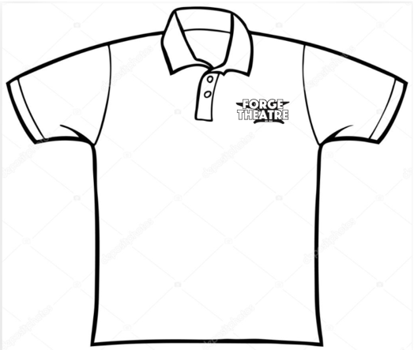

Forge Theatre
Polo Shirt
Order Form
(Grey shirt with logo embroidered in white)

Name: ________________________________________

Phone Number: ________________________________

Shirt Size: (Polo Shirts are $25, $1 extra for each size over XL)

SIZE Cost X Number = Total

SMALL $25 X ________ = $ ________

MEDIUM $25 X ________ = $ ________

LARGE: $25 X ________ = $ ________

X-LARGE: $25 X ________ = $ ________

2 X: $26 X ________ = $ ________

3 X: $27 X ________ = $ ________
Make checks payable to Forge Theater and mail to:

Forge Theatre
Attn: shirts
P.O. Box 474
Phoenixville, PA 19460

TOTAL # OF SHIRTS: ________

TOTAL COST OF ALL SHIRTS: ________

